08th July, 2021
NITA-U Launches Cyber Security Awareness Campaign
The National Information Technology Authority Uganda (NITA-U) has today launched a Cyber Security Awareness Campaign aimed at increasing the public awareness and vigilance about the day-to-day cyber threats.
The campaign is funded by the World Bank as part of the Regional Communications Infrastructure Project (RCIP).
RCIP Uganda has focused on complimentary infrastructure investments to ensure greater access to affordable, high quality Information and Communications Technology (ICT), and development of a range of enabling e-Government foundations such as shared infrastructure and e-services for MDAs (Ministries, Departments and Agencies) among other interventions.
With increased access to internet through the extension of affordable broadband, there is bound to be an increase in the number of internet users in the country and thus more risks to cyber threats to users who are unaware of cyber security mechanisms online.
The NITA-U Information Director, Mr. Arnold Mangeni said; “As the total number of internet users continues to grow, we’re launching this campaign with a goal of raising awareness about the cyber-related threats out there and to empower the Ugandan citizens with the knowledge and sense of shared responsibility to practice safe and informed decisions while using the internet.”
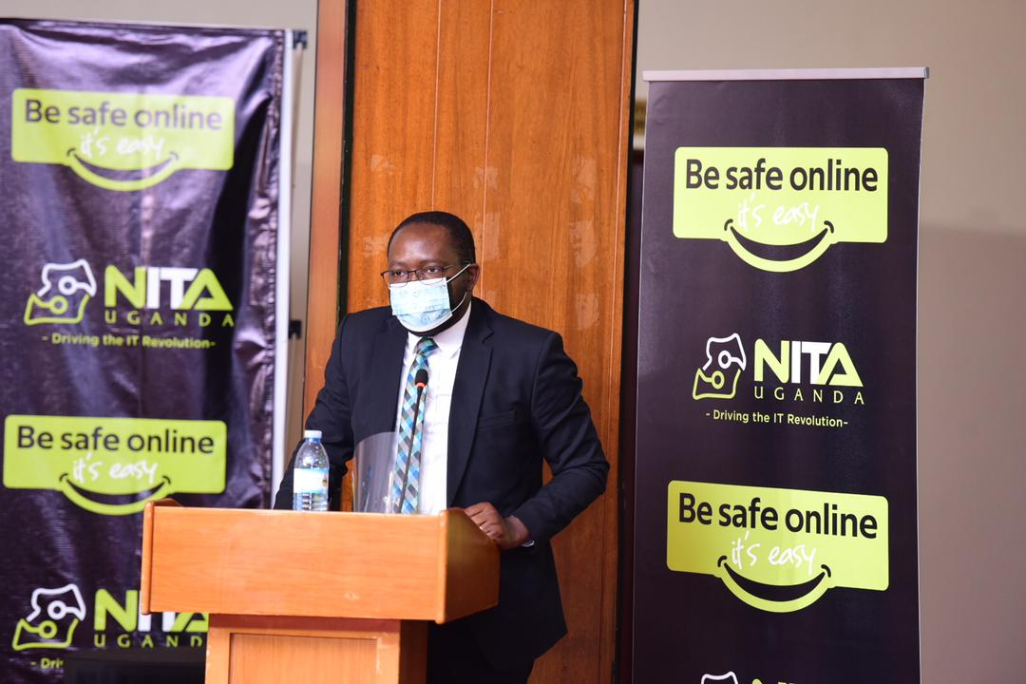
Figure 1Director Information Security, Mr. Arnold Mangeni addressing journalists at the launch of Cyber Security awareness campaign
“We need to remember as technology users that safeguarding the Internet is a responsibility we all share. Digital technologies and the Internet have transformed our everyday lives since we can now access information, conduct business, keep in touch with family and friends, and engage online, but we need to remember cyber-attacks are becoming more common,” he added.
Cyber threats in Africa and in Uganda have increased over the years in terms of frequency and sophistication. Cybercrimes reported to the Uganda Police Force (UPF) have increased from 62 cases in 2013 to 198 cases in 2018 which results into the losses in hundreds of millions of shillings. Among the cases handled by police, there included offences related to electronic fraud, threatening violence, defamation, offensive communication, impersonation, cyber harassment, theft, pornography among others. On the side of proactive protection measures, NITA-U has in place the Uganda National Computer Emergency Response Team and Coordination Center to effectively analyze and respond to cyber threats for better protection of Uganda's critical digital infrastructure and the availability of dependent services and support provided to government agencies, citizens and businesses.

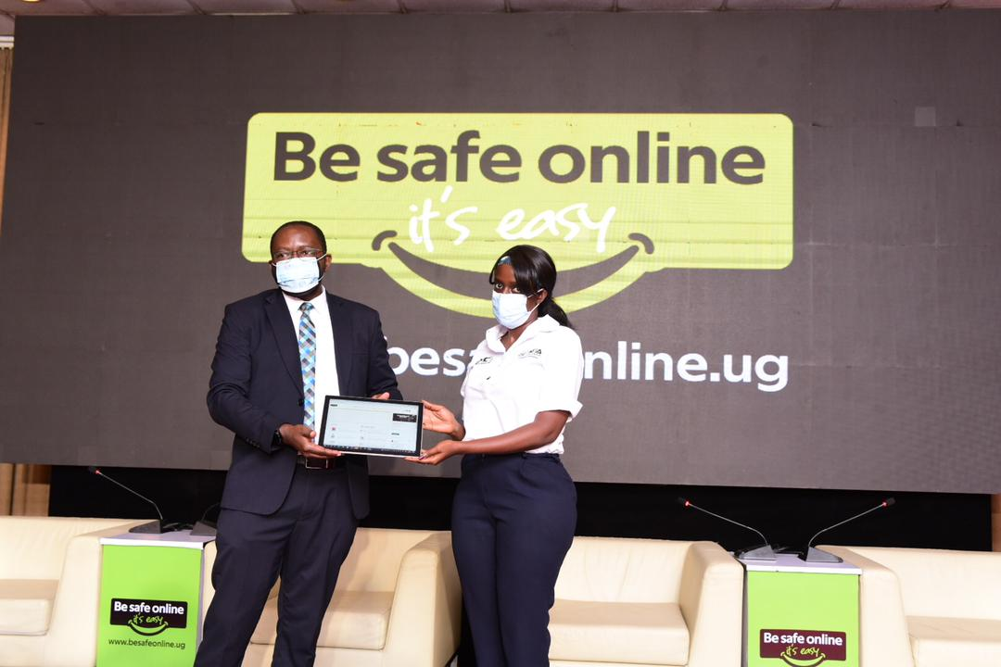
Figure 2 Director Information Security, Mr. Arnold Mangeni and Ag.Communication Specialists Ms. Angela Ndagano launching the Cyber Security awareness campaign
All these present a risk to the current internet user in the country and more awareness of the risk of falling prey to this threats is important to protect the users online.
With the launch of the Cyber Security Awareness Campaign “Be Safe Online” NITA-U continues to deliver on its promise of safeguarding the Ugandan people every step of the way.
Users can follow campaign content online through the website, www.besafeonline.ug or on social media Twitter @NITAUganda1 Facebook: NITA. Uganda. Instagram: nitaug
-END-

For more information: pr@tbwa-uganda.com
About NITA-U:
- The National Information Technology Authority-Uganda (NITA-U) is an autonomous statutory body established under the NITA-U Act 2009, to coordinate and regulate Information Technology services in Uganda.
- NITA-U is under the general supervision of the Ministry of ICT and National Guidance.
- NITA-U believes in the ability to seek new ways of doing things efficiently to deliver value to our customers. We strive for technological advancement in relation to global IT trends and becoming a national premier IT organization.

